

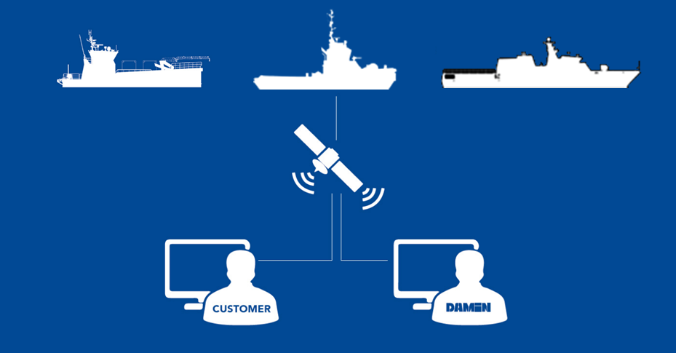

For in-house purpose only

Author : Damen Digital  
Date : August 25, 2017

Table of Contents

1 Introduction - Aim, Role and Scope 4

2 Organisation 6

2.1 Core team 6

3 Vision – Mission - Strategy 8

3.1 Vision 8

3.2 Mission 8

3.3 Strategy 9

3.4 Critical Success Factors 10

3.5 Approach 10

3.6 Standard solutions 10

3.6.1 Platform 11

3.6.2 Applications 11

3.6.3 Internal 13

3.6.4 Data Science 13

3.6.5 Vessel 15

3.6.6 OEM partnering 16

3.6.7 Damen Digital Services 17

3.6.8 Unmanned & autonomous sailing 17

Communication 19

3.7 External communication 19

3.8 Internal communication 19

4 Financials 20

4.1 Benefits 20

4.2 Competitors offerings 21

5 Planning 22

6 Annex A – Detailed responsibilities team members 23

**Document Version Control**

|  |  |  |  |  |
| --- | --- | --- | --- | --- |
| Version | Date | Author | Distributed to | Remarks |
| 0.1 | 22-3-17 | Sander Alles | Toine, Rutger, Marco, Boudewijn | First draft |
| 0.2 | 27-3-17 | Sander Alles |  | Descriptions of deliverables added, Streams added |
| 0.3 | 5-4-17 | Sander |  | PSC deleted, chapter Roles and responsibilities needs to be added |
| 0.4 | 7-4-17 | Sander |  | Add swimming lanes / Digital transformation |
| 0.5 | 10-4-17 | Sander |  |  |
| 0.6 | 11-4-2017 | Toine |  | Added comments |
| 0.7 | 16-4-2017 | Rutger |  | Added comments until 2.3 |
| 0.8 | 20-4-17 | Sander |  |  |
| 0.9 | 24-04-2017 | Toine |  | Comments |
| 1.0 | 20-5-2017 | Rutger |  | Intro adjusted and text added or reviewed in line with PPT |
| 1.1 | 23/24-5-17 | sander |  | Enhanced readability through accepting changes.  Removal of “Digi” terminology |

**Document References**

|  |  |  |  |
| --- | --- | --- | --- |
| Document name | Version | Date | Author |
| Digital Transformation summary.docx | 1.0 | 6-4-17 | Sander |
|  |  |  |  |
|  |  |  |  |
|  |  |  |  |

# Introduction - Aim, Role and Scope

The digital transformation of “the world” is in full effect. The speed in which developments take place is incredible and generate a lot of possibilities. Across all industries, companies are offering integrated bundles of products and services as complete solutions complementing their existing offerings.

Servitization is the movement of companies towards offering products together with value-adding services in order to fully address customer needs. Through servitization, shared value is created for the company and its customers. In the shipping industry, only few companies have *servitized* their offerings.

**DEMAND:** Damen customers generate an increasing demand for relatively simple applications specifically focussed on assisting the operation of vessels. Examples of such are applications displaying the fuel consumption, components statuses or location information. From a Damen perspective, these applications can be translated into services and can generate valuable information regarding the operation of our designs and systems.

**AIM:** Damen Digital will guide our company in the creation of digital services. Our large installed base enables us to generate turnover to – partly - compensate development costs. We will take small but fast steps where the combination of applications is expected to provide again new services. This approach will ultimately lead to our desired end-state; one where Damen can provide complete assistance to its customers in helping them to keep their vessels in operation;

Assistance in Asset Management.

Ultimately, the knowledge gained and the systems created will enable Damen itself to offer Asset Management as a product. This implies that without transferring the ownership of the asset the next possibility will be;

Operational Lease.

In addition will Damen Digital create the fundament for future developments regarding remote controlled or even autonomous sailing vessels.

**ROLE:** In recent years various initiatives have been taken on the subject of monitoring and digitization of ships. This subject is popular and thus the number of development initiatives, both outside and inside Damen, increased over time. Damen Digital will coordinate the development of digital systems and services. We aim to create maximum synergy and realize a single, robust and reliable data platform enriched with applications and (commercial) services. It is important to note that we aim to guide and steer and not to create. The latter activity will remain the responsibility of the line organization.

**SCOPE:** When valuing digital services, the demand creating drivers from a client perspective can be divided in cost saving – and revenue driving elements. Ultimately, all initiatives should be aimed at either a more efficient or effective utilization of the vessel and its systems. The figure below displays the various elements.

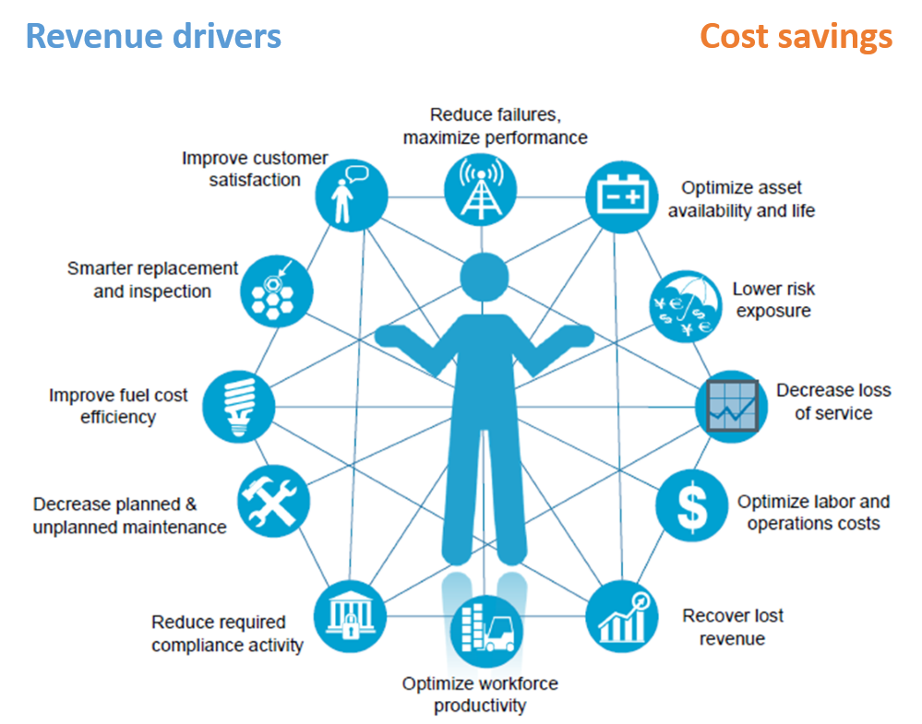

Damen Digital will focus on transferring operational data to shore and translating these data in valuable information for clients, Damen and third parties. Digital Services will be developed based on the operational information combined with design knowledge. Damen Digital should be seen as the follow-up and continuation of current monitoring related projects such as the Tugs vessel monitoring implementation activities, the DCR-project ‘Vessel Monitoring’ and the ‘Damen Performance Solution’ project.

The Damen Digital team will have a coordinating role in all digital related initiatives. The Damen Digital development is closely related to the on board automation development. The on board automation system will be the fundament of the on board digital infrastructure. The mechanical, electrical and automation system developments itself will not be part of the scope of Damen Digital. However Damen Digital will be responsible for successful integration of digital developments into the on-board system developments and the on-shore data system integration developments.

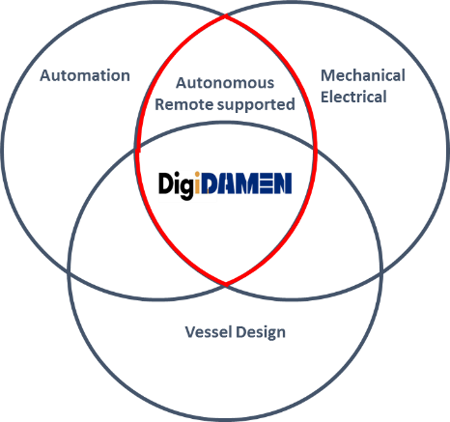

Based on the operational data it will be possible to support the vessel operator through operational consultancy services. It will even be possible to actively intervene in the ship operation from shore. Damen Digital will be responsible for the transition of vessel monitoring capabilities in to remote support and the initial phases of the research into possibilities of Damen remote controlled or autonomous sailing vessels.

# Organisation

Damen Digital consists of 5 members in a core team. This team is responsible for the realization of the Damen vision and strategy on (commercial) digital services. Their activities are conducted in close cooperation with all connected colleagues in the line-organisation.

The core team of Damen Digital consists of following persons:

Toine Cleophas (R&D) Damen Digital program manager

Sander Alles (Product Manager)

Rutger Blaauw (Services)

Boudewijn Baan (Sales)

Marco Mooij (Product Groups)

The team will report to the sponsor group as displayed in the chart below. This sponsor group will support the project team, enable and consolidate the process developments and communicate to the EB, CNBD and IT-IM board.

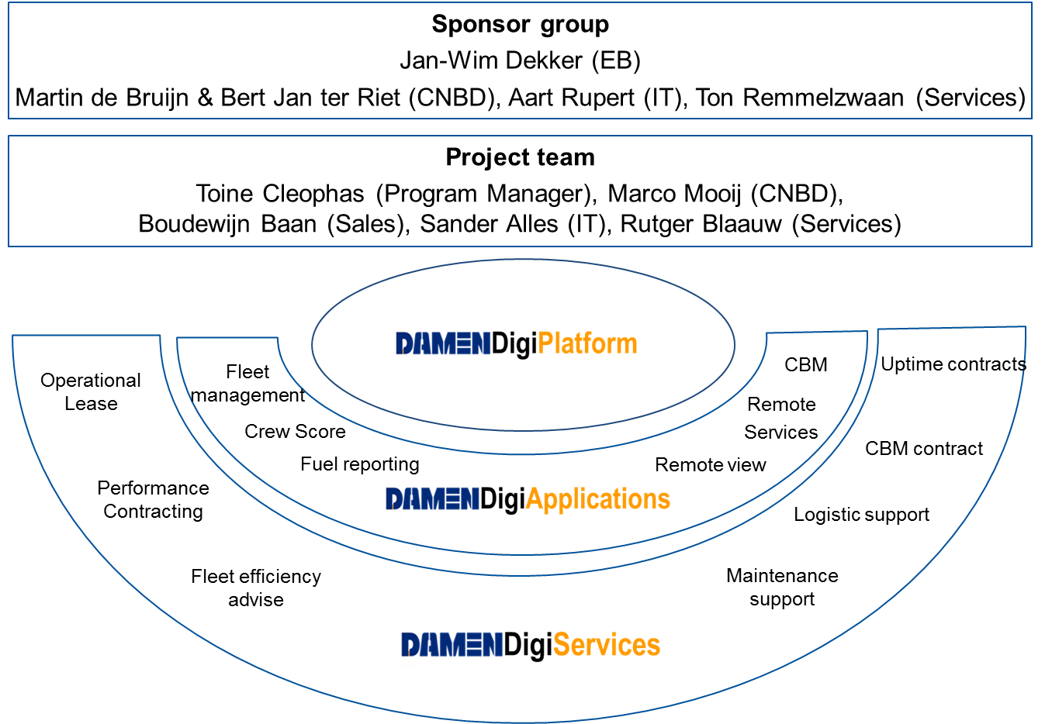

## Core team

The team consists of five distinct roles:

● Strategy, coordination & data science Toine Cleophas

● Sales & Business development Boudewijn Baan

● Damen Digital Platform and development Sander Alles

● On board infrastructure (link to vessel automation) Marco Mooij

● Damen Digital Portal & Services Rutger Blaauw

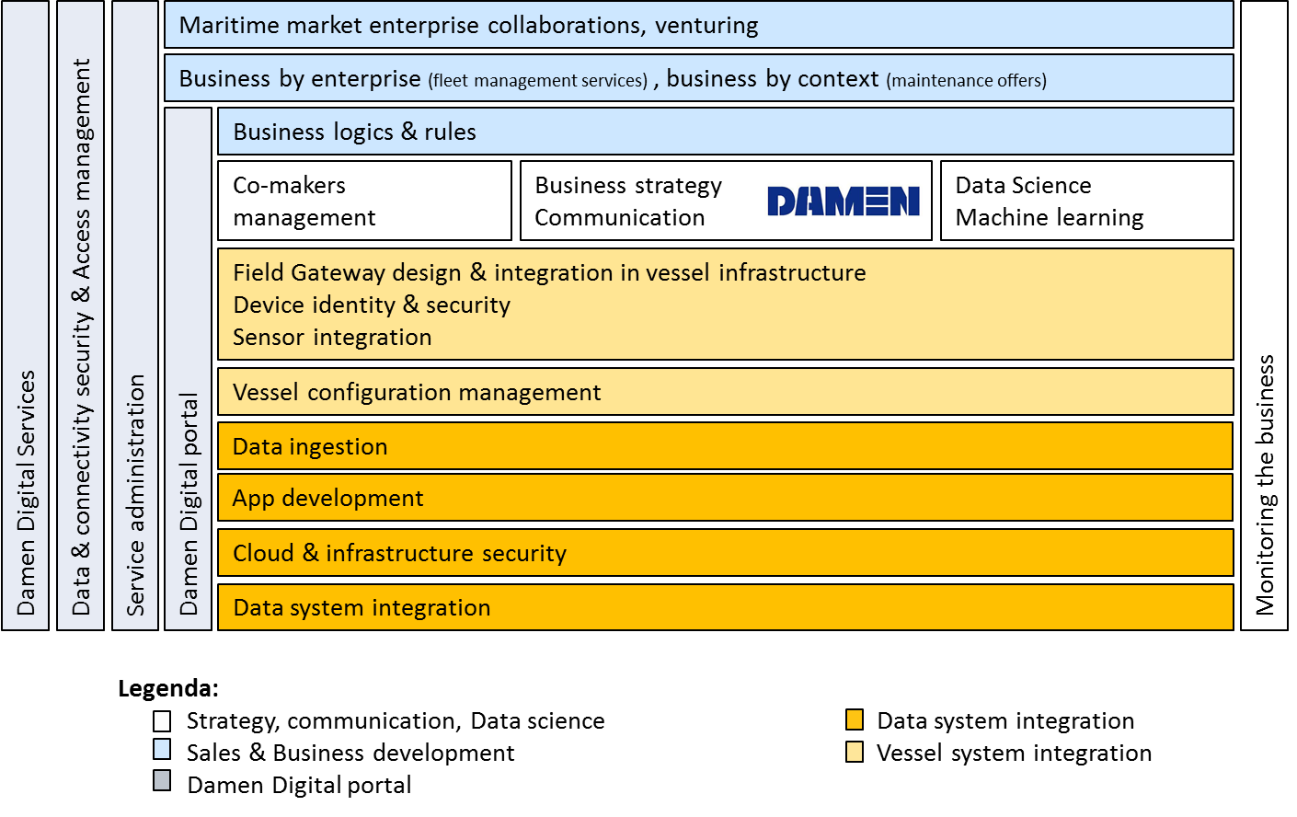

# Vision – Mission - Strategy

## Vision

Damen Digital envisions all Damen vessels remotely connected to interpret operational information for both internal and external use. We believe that Damen should provide full support to vessel owners in managing their assets. By connecting vessels to a secure network Damen will be able to analyse the generated data and support clients in their mission to keep assets available for operation anytime and anywhere.





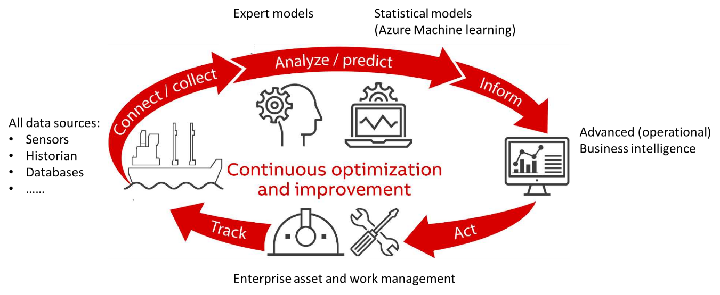

## Mission

The Damen Digital team is leading the strategic development activities of all Damen departments related to the digital operational data from vessels.

Our mission is to integrate all efforts relating to the digitization of our Services and Products and steer them to the common goal; full asset management leading to operational lease.

We will urge all to embrace a common strategy in this venture. Boundaries between departments will need to be eliminated, the so-called silos cannot exist if we want this to succeed.

Our mission is to get all aboard, show each individuals role and make sure this new way of adding value to our customers is embraced by all; from cradle to grave.

## Strategy

Our strategy is to focus on the continuous development of applications and services based on the gathered data. With the end-state of Asset Management in mind, we will concentrate on developing applications and services which are feasible to realize with the available data and knowledge. We will:

**Think big – act small – scale fast**

The figure below describes our desired steps. We know that decision automation is key to provide sound and realibale predicitons based on Data analytics, but we realize that Damen first needs to be able to describe and diagnose remotely prior to providing such services.

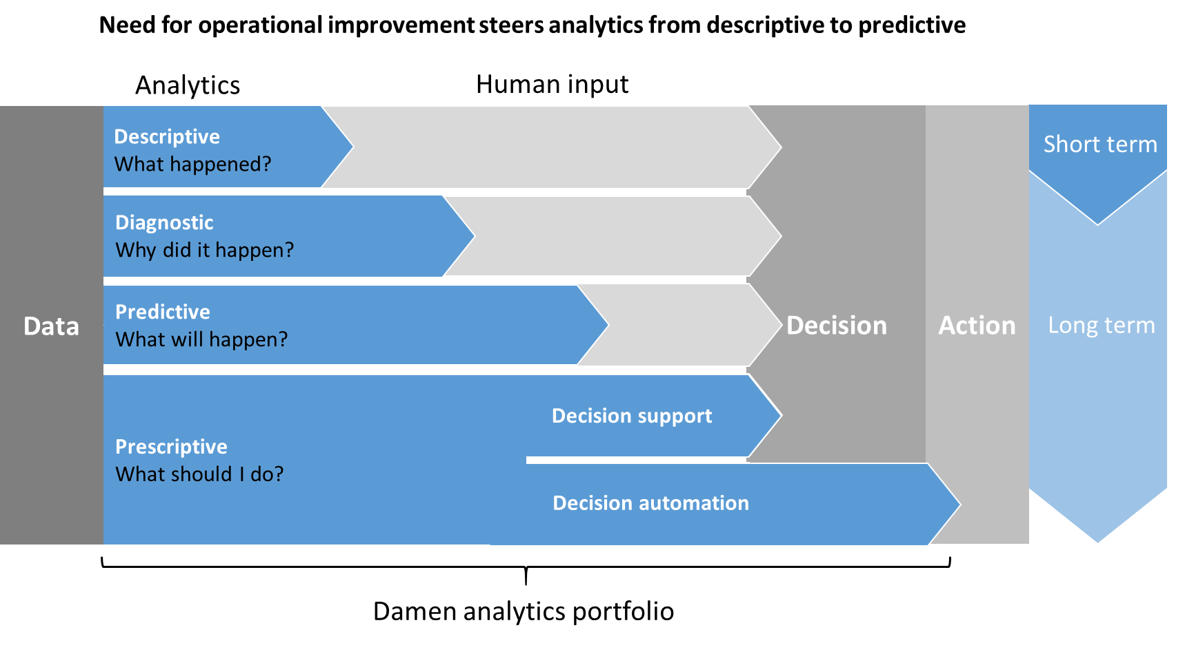

Damen Digital will first focus on the development of a Damen wide platform which supports: incoming data, data processing and data visualization. In parallel, a standard solution will be developed for vessels to be retrofitted so they can transmit data to this platform. The first apps will be relatively simple to build, and will generate useful information for customers. These apps can then be sold to customers. This income should be used for further developments. It is likely that product groups already want to join in the solutions that are available.

The development of new apps should be decided by the Damen Digital team. This team will facilitate governance where new ideas will be pitched and challenged by different stakeholders. The stakeholder group should include at least one member of sales, each product group (Dredging, Naval and Amels considered as a product group), the Services department, Group IT-IM, cluster repair, market intelligence,

The data is gathered on a platform and will be converted by IT-IM into information used internally in order to enhance future ship designs (i.e. insight in real operational profiles). Furthermore, relevant information can be presented to customers. This service could either be provided for free in order to create USP’s for Sales or be delivered as a paid service.

The delivery of these “apps” to customers does not impact the Damen organization. Whenever services are provided which use the information from apps and other data from the platform, this might change.

Ultimately, the different apps, applications and services combined could lead to information required in order to (Operational) lease vessels to customers. (Power by the hour)

This will definitely impact the Damen organization (Examples to be given, details in a later chapter)

It should be noted that the developments in the digital are at such high pace, that it is likely that the goals will shift. Please refer to the document “Digital Transformation Summary”.

## Critical Success Factors

* Commitment from the board
* Willingness of the organisation to change (report Erik Klok)
* Maturity level stakeholders involved
* Willingness to accept - embrace Out of the box ideas
* Permission to (partially) fail (failing is learning)
* Killing of NIMBY
* Acceptance of Services and Group IT-IM as a business partner
* Servitization is part of the strategy of Damen
* Commonality of parts and systems over and at least within Product Groups
* Suppliers are treated as Partners; Purchasing needs to embrace the integral approach and
* Governance structure for Damen Digital
* Resources are available
* Ability to outsource different developments
* Ability to analyse the incoming/existing data
* The elimination of silos and the willingness to share knowledge and fully cooperate as one DAMEN

## Approach

In order to deliver (combinations of) apps to customers, basically 2 Groups of Damen customers can be distinguished: customers owning vessels which need to be retrofitted, and future customers which shall receive vessels which (are prepared to) deliver data.

The organisational set-up and approach of Damen Digital is aimed to realize, maintain and manage the following short term deliverables:

* A Damen owned “**Damen Digital Platform**” which will be the single source for **all** vessel data and the enabler of applications and services.
* The first deliverables coming from “**Damen Applications**” will be the market introduction of two Damen remote monitoring applications, ready by Christmas 2017 and available on your smartphone and tablet.

## Standard solutions

The goal is to determine a standard solution (Based on the retrofit solution) which will be installed on vessels being built from 2018. This solution should be available for engineers in the design phase and the cost should be low enough to install it on every vessel produced by Damen. This standard solution should be developed using a “Freeze and Release” methodology. The roadmap will depend on other department achievements too, meaning that i.e. a more detailed monitoring solution of HVAC could be depending on what the purchasing department orders at an HVAC supplier. As the document “Digital Transformation Summary” stated: effective collaboration between departments is required.

4 parallel streams have to be finished.

Platform – Applications – Damen Internal – Vessel

Description per stream:

### Platform

The objective of this stream is to provide in a platform and governance structure which will serve as the main platform for Damen in order to provide (Paid by customer or “free as USP”) applications or services to end customers. This stream will deal with all aspects of the platform. Next to the physical components being installed / Managed / Maintained by IT, different aspects should not be disregarded like Governance, Design Policies and Security.

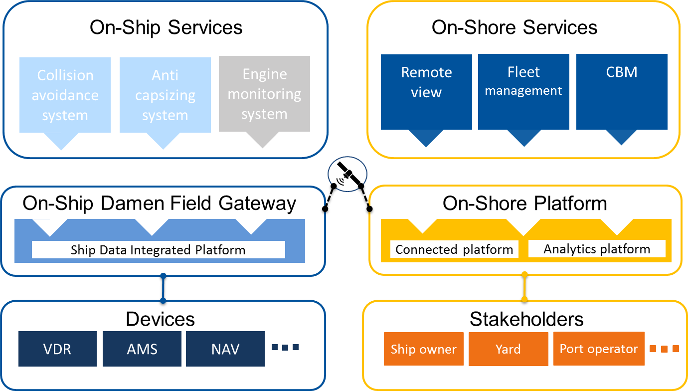

### Applications

This stream will deal with the different applications that will be developed on the platform. These applications can either be sold or given for free to customers individually. Combinations can be made between applications that will create a Service to customers. Ultimately, a range of different applications will be required to start an “operational lease” service.

All aspects regarding the development of this functionality will be dealt with in this stream.

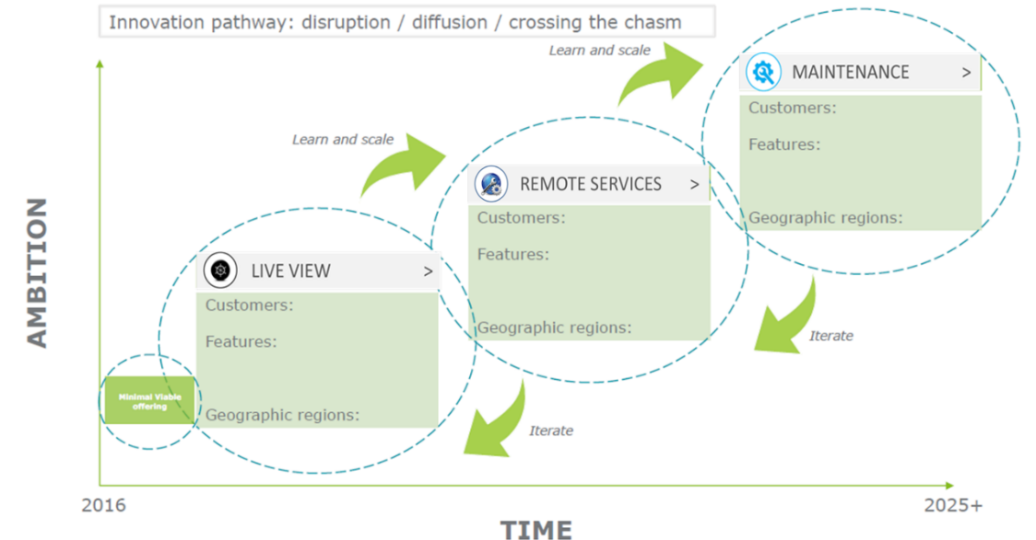

**Dashboard library**

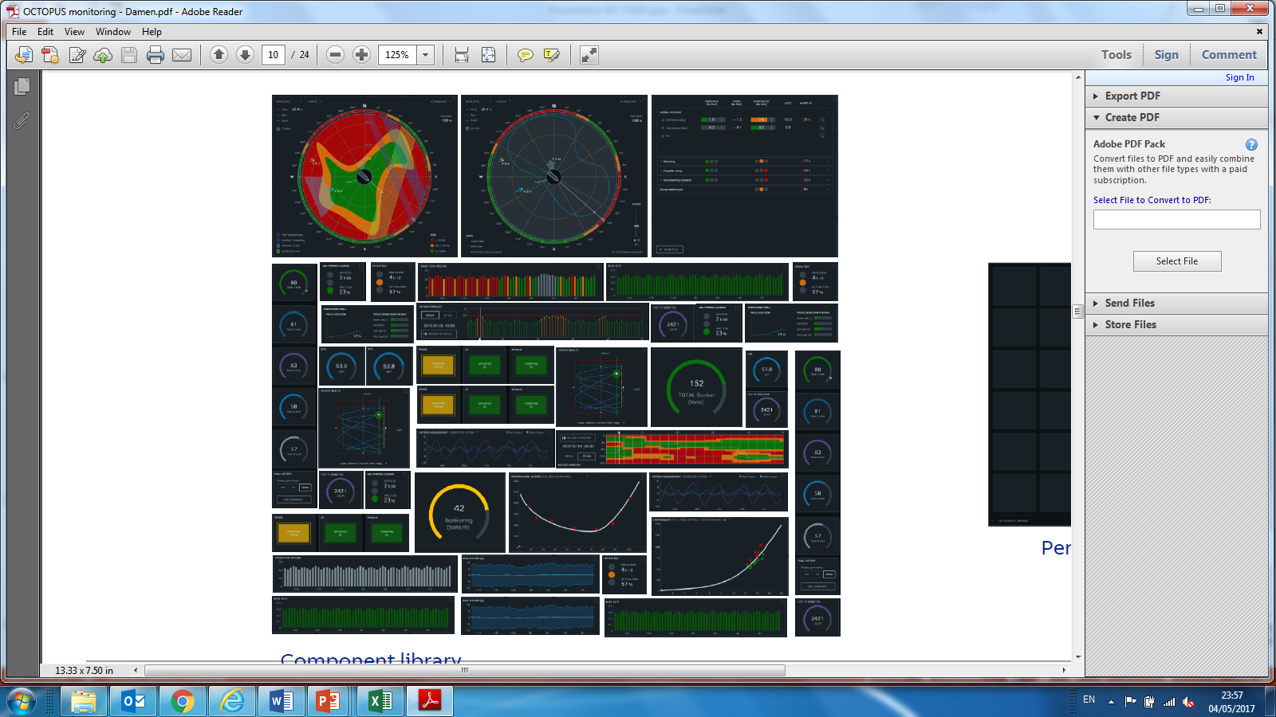

### Internal

The platform will only be as good as the content it will hold. At this moment, the content foreseen to be used is not on a level where it should be. Later in time, depending on the successes and requirements of customers and our internal organization, this means that our own organization needs to understand that the management of data is of vital essence for the success of the solutions that will be developed. Master Data, Meta Data, Part Catalog data, etc. will need to be updated/upgraded to an acceptable level of quality. The sooner this will be the case, the sooner the solutions will be elevated to a high level.

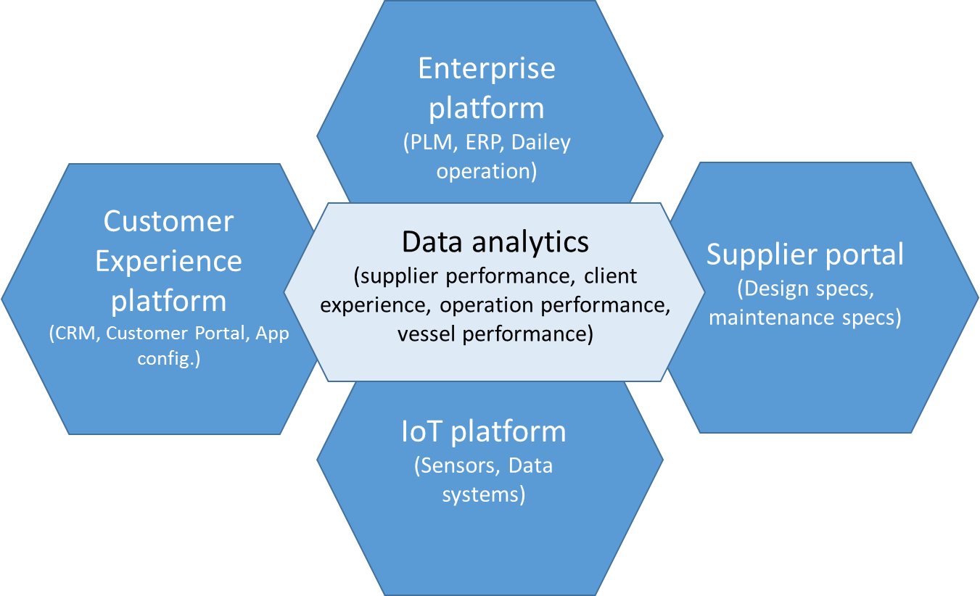

### Data Science

Combining data and analysing it in an effective way will result in enraged information for the user or for Product Groups. A team will transfer data into information. Damen has a rich history in data analytics and has a large database on powerful data science applications which will be utilized in Damen Digital Applications.

**Expert models:**

The expert models are based on physics, experience & supplier knowledge and are proven to be effective on both diagnostics of failures and performance predictions or assessments. The expert models are both in time domain and frequency domain.

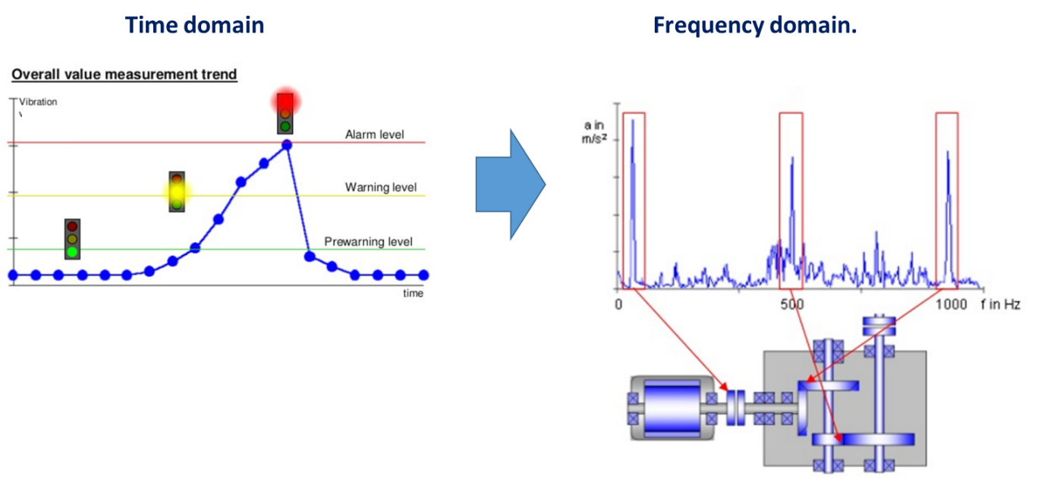

The power of frequency domain analyses is explained in following graph.

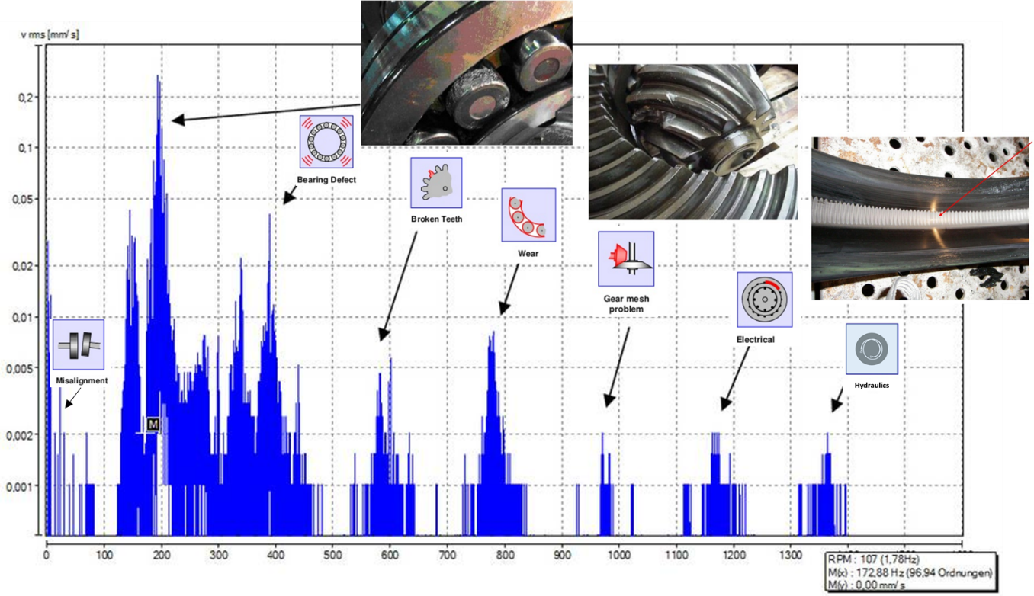

**Statistical models:**

The statistical model approach is most powerful in deriving patterns, triggers of failures or efficiency assessments. The power of statistical analytics is explained in following picture.

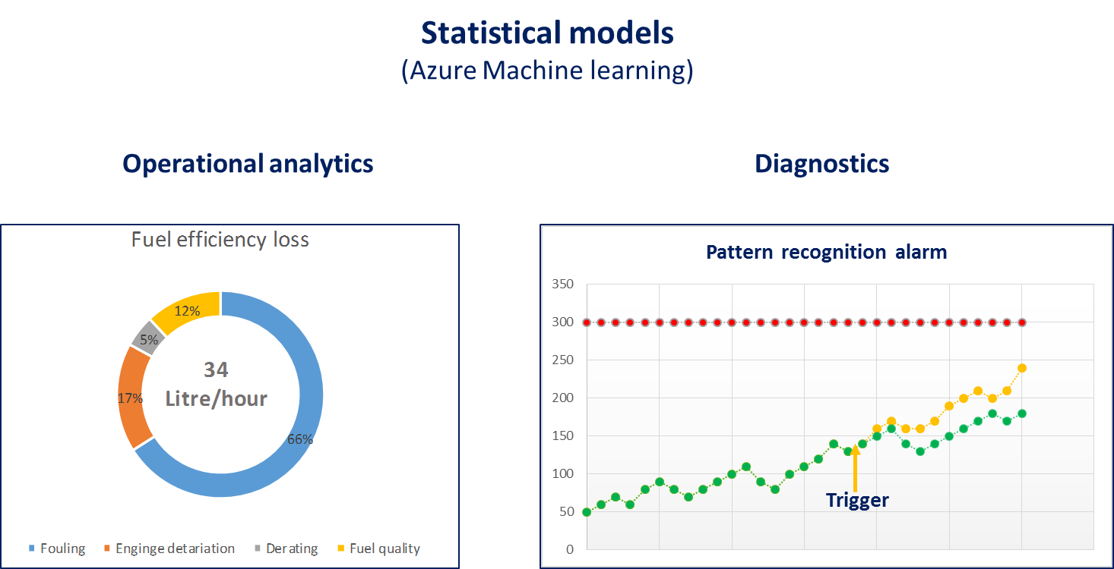

Damen Digital will translate the (Existing?) data science knowledge of Damen in the Damen Digital Applications. Power BI will be one of the tools which used for the Cloud based data analytics.

### Vessel

The vessel stream will deal with the required installations and modifications on board of vessels. It is required to install sensors on board of the vessel on strategic locations. This data, together with data which already exists on the vessel should be transferred to the Damen Platform. In order to realize this, a comprehensive solution needs to be designed, as well as installation instructions. Preferably, these solutions are equal over Product Groups.

The configuration of the vessel is defined in engineering stage. The vessel configuration is the fundament for Damen Digital. Knowing which components, systems and sensors are installed is of utmost importance to be enable operational consultancy, like CBM or fleet management.

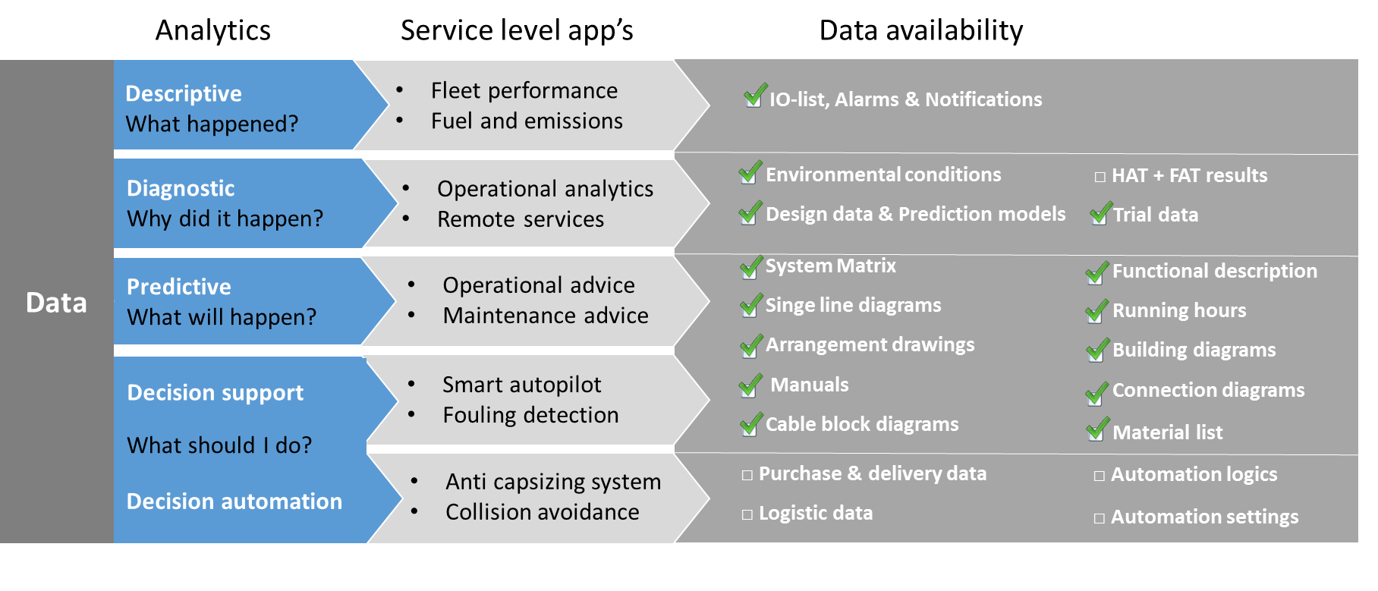

Thus, during the process of engineering it becomes even more relevant that design data is stored in documents and data systems. A single source of data and information makes it possible create a reliable and maintainable design data base. Adjacent developments like the introduction of IFS, PLM and programs like Excellerate do contribute to this challenge of making design data available.

The current process of engineering and the design documents which define the vessel, are displayed in the picture below. This process will not only result in single source and absolute design data, but will also result in increased commonality in vessel (system) designs.

Big data lives by the sake of having data available to analyse. The sooner vessels will generate data, the better. The sooner the design data is available from a single source the easier it will be to support our clients by game changing operational advise!

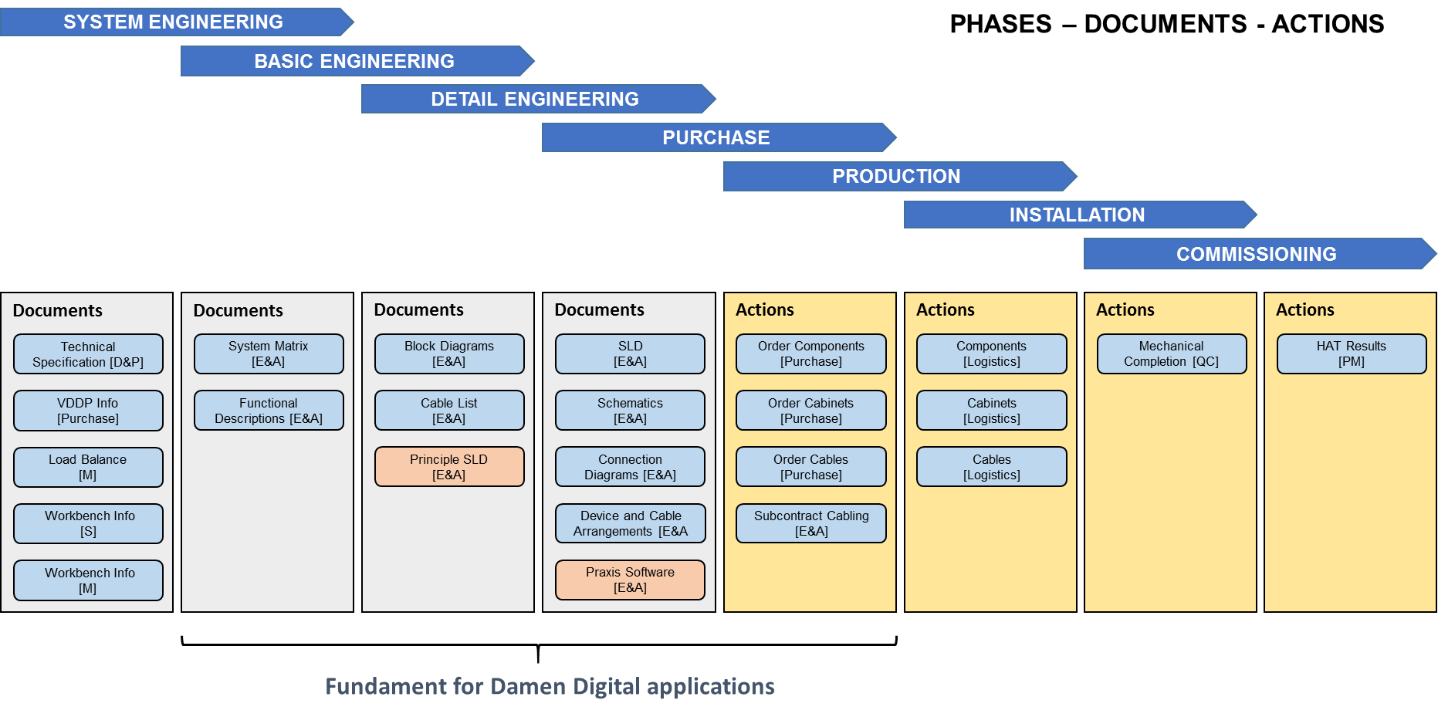

### OEM partnering

OEM Partnering (supply chain collaborations)  
Configuration management high over, Suppliers and Sub suppliers in detailed level. All systems and components are in continuous development. These developments do influence the configuration, performance and maintenance. Like Damen also our partners in the supply chain phase the challenges and opportunities of automation and digitalisation. There victories in innovating there systems and component are also Damen victories, as long as we are able to adopt them. In many cases we can challenge our suppliers based on the opportunities we see for them in Maritime Industry. Out partners like to invest their development budget in technology they can sale. We are their client, and should be able to utilize their innovations by managing the stakeholders. A yearly development agenda and outlook by Damen is one of the tools for making this happen.

For this reason it is a good idea to have our Purchase Director being seated in the Sponsor group.

Basically their two reason for OEM partnering.

1. Configuration management  
   The configuration of our vessels and especially of the on board digital infrastructure, from sensors to data processing and on board analysing.
2. Asset knowledge and monitoring developments
3. Damen Digital Services - Parts supply

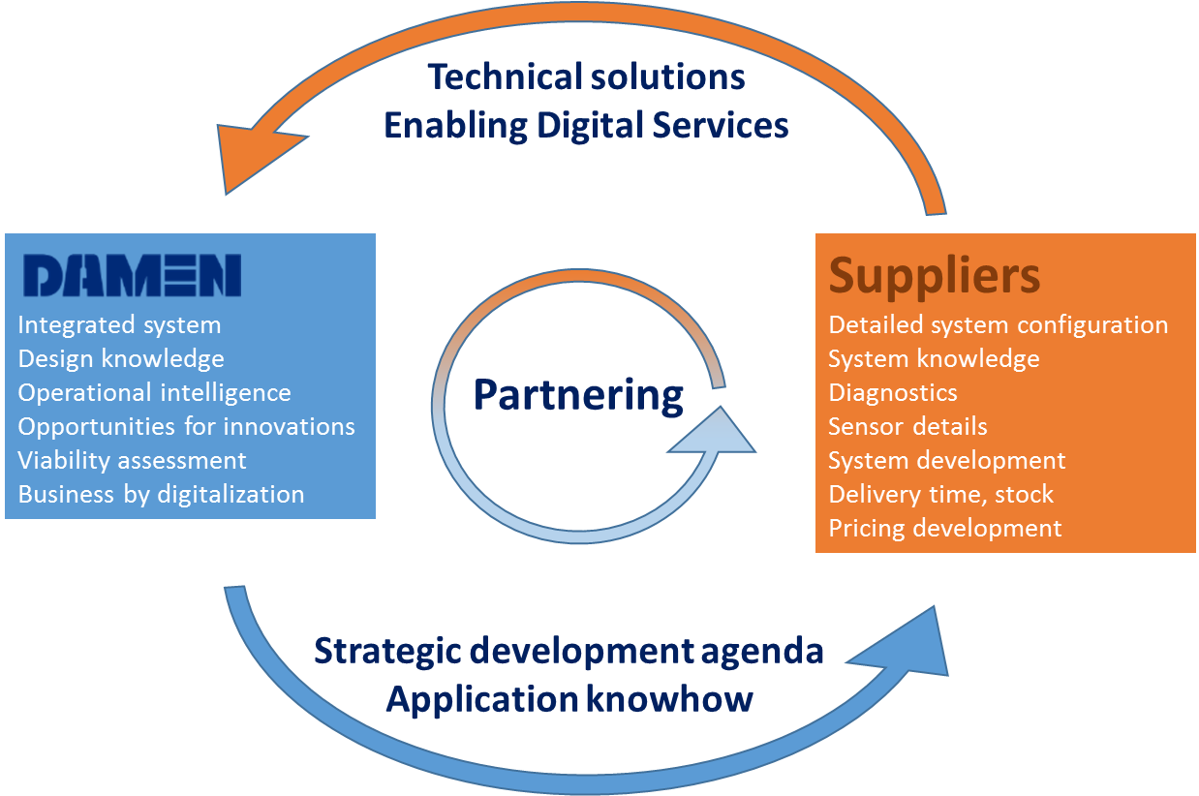

### Damen Digital Services

Damen Digital will enable two kind of services; after sales maintenance related services and operational consultancy which is aimed to improve profitability of the operator.

The role of Damen Digital in the after sales & maintenance related services is explained in following picture.

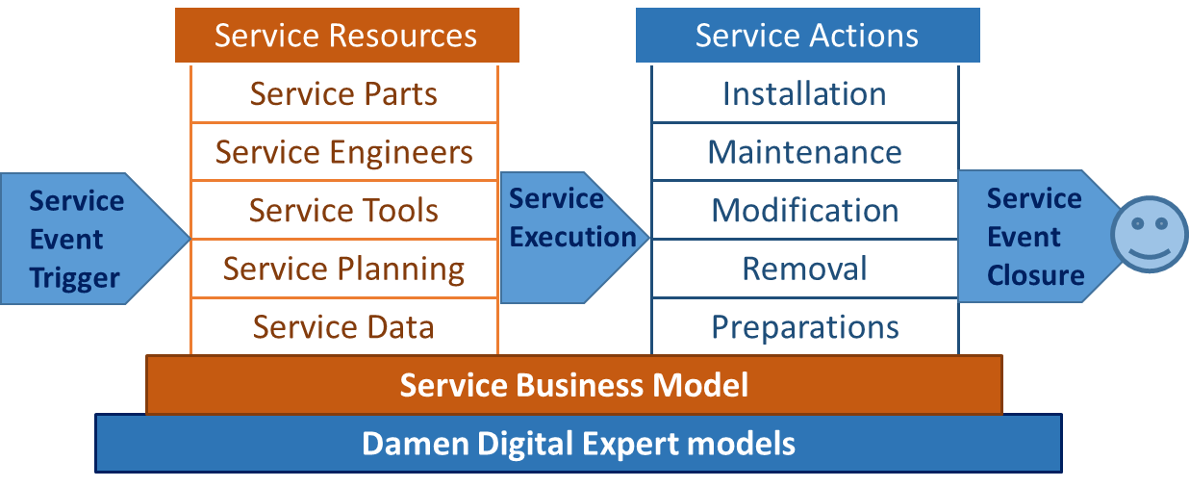

The role of Damen Digital in operational consultancy is explained in following picture.

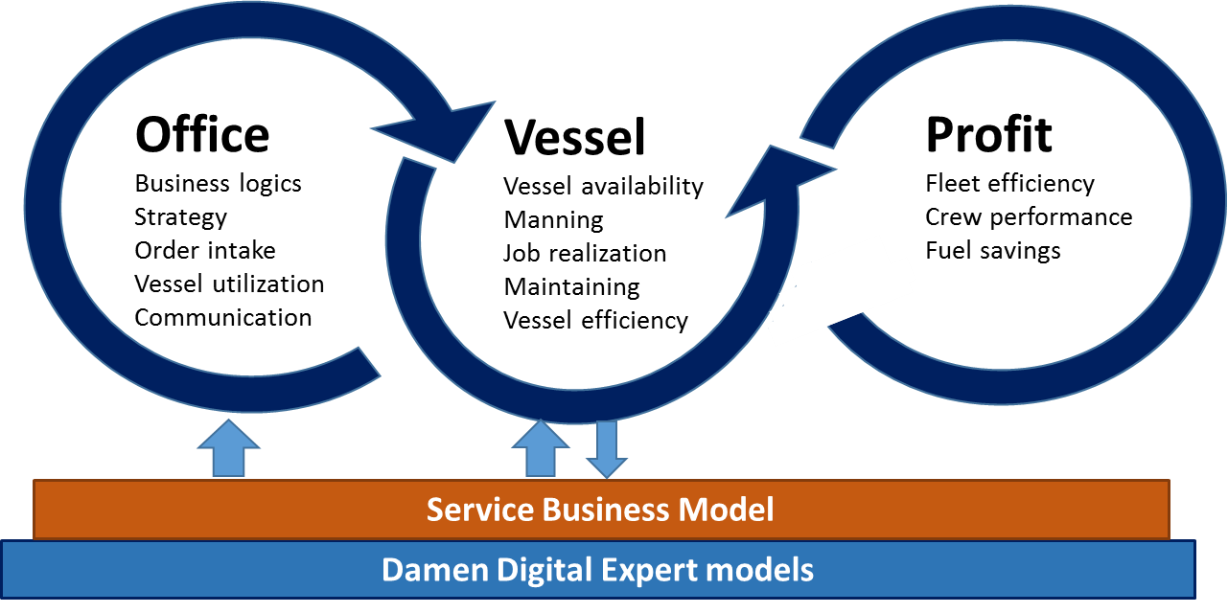

### Unmanned & autonomous sailing

Damen Digital enabling Autonomous sailing development

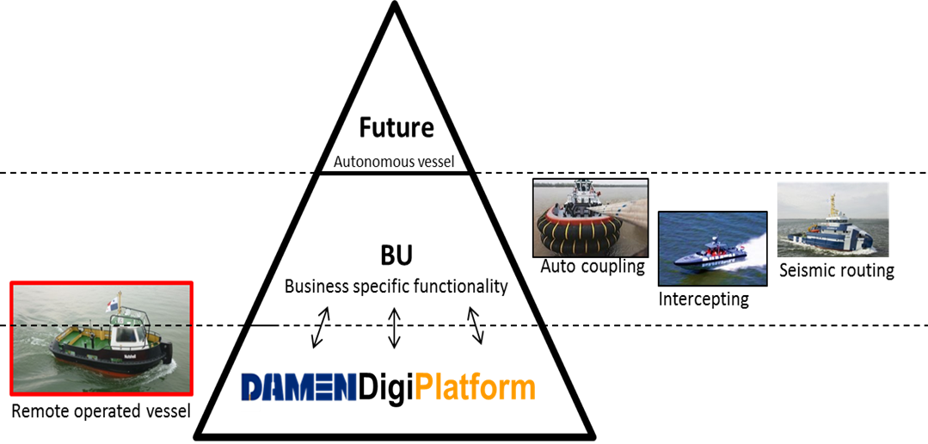

The scope

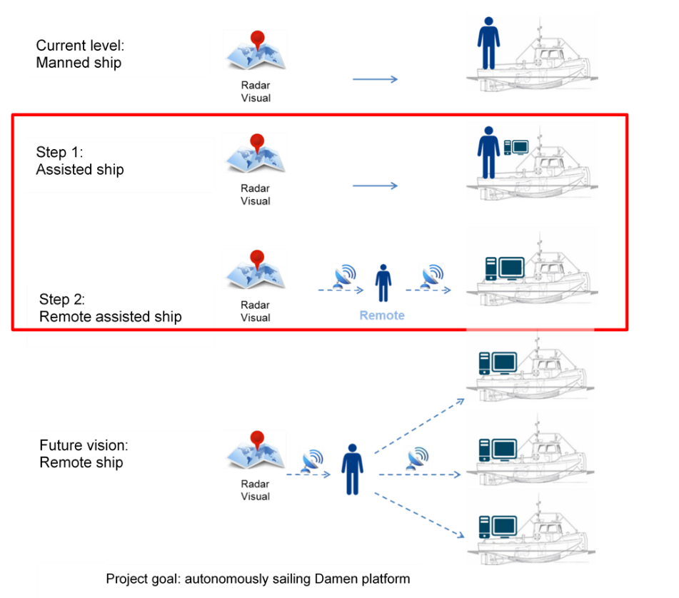

# Communication

## External communication

## Internal communication

Intranet

Damen nieuws

Website – voorstellen – doelstellingen

Maandelijkse lunch meeting

# Financials

## Benefits

Currently, several IoT development initiatives have been approved, which, so far, would be realized in isolation. All of these initiatives need a digital platform so the Damen Digital initiative will bring efficiency in realizing one Digital Platform which supports these initiatives.

Besides this, several customers have shown interest in the use of applications which require a digital platform. Until now, this would have been delivered using third parties resulting in more cash out (Assuming that more customers require the same applications) and loss of valuable information due to not having a Damen Digital Platform (the data would have been stored elsewhere).

**Original budget Current budget**

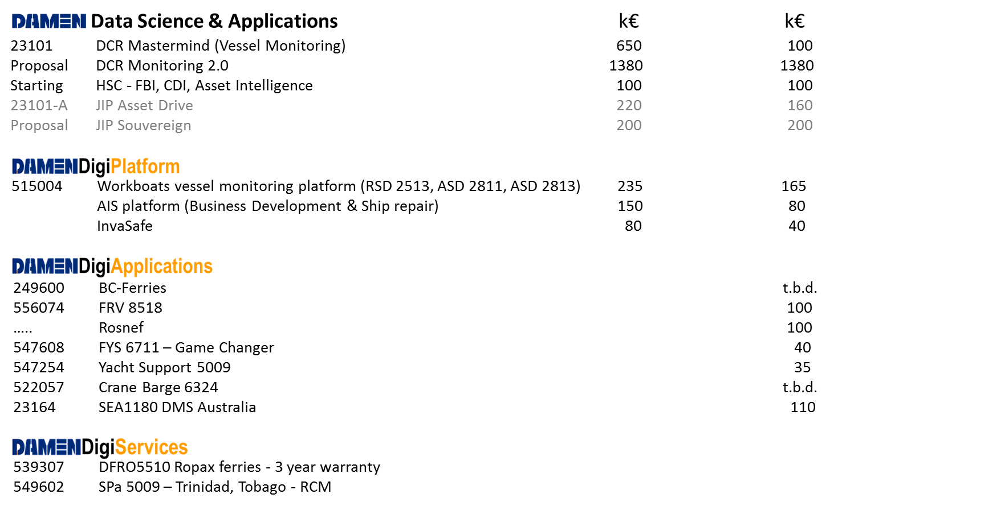

Currently, an investigation is running for gathering the (internal) customer requirements and remaining budgets which will provide an overview.

Having the platform and a set of applications ready will likely result in the sale of more (of the same) applications.

As written before, a target is also to gather the on board alarm monitoring information. This will enable Damen to provide a new service: remote assistance. Based on the customer requirements this service could be commercialized.

Having all of the targeted information available, this will lead to more services that could be provided:

Commercial offers for overhauls, docking parts delivery, Training, in fact, all of the existing services offering will be boosted.

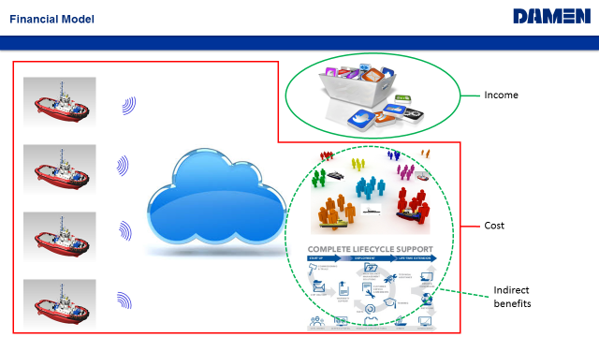

## Competitors offerings

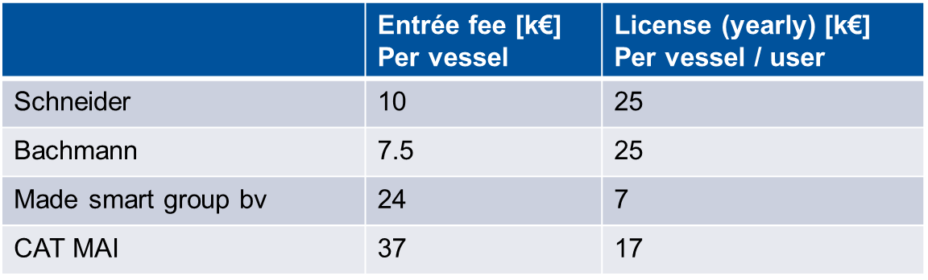

# Planning

1st sprint: basic infrastructure + Connected Ship app + Remote Services app

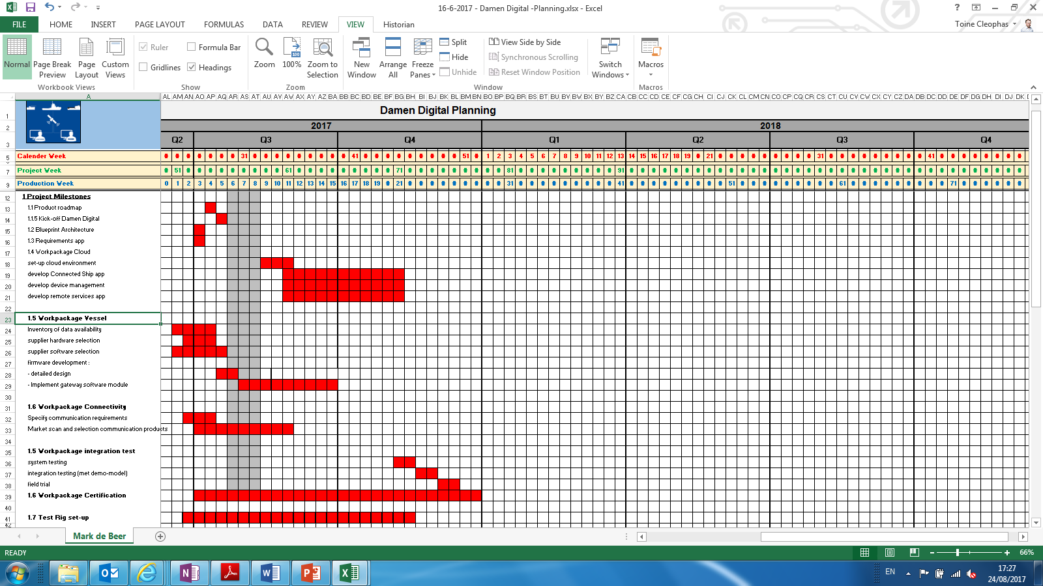

# Annex A – Detailed responsibilities team members

The responsibilities are divided over the Damen Digital team members.

**Boudewijn Baan; Sales & Business development**

* Provide sales support to the various sales organizations and keep an overview of all ongoing initiatives with expected delivery date and explain the added value for each stakeholder.
* Stay in close communication with our marketing department
* Sending regular updates on ongoing initiatives to the various sales organizations
* Translating market demands to prioritised ongoing initiatives
* Internal communication within the Damen organization (Intranet / Lunch meetings / …..
* Communicate with customers on the progress on relevant initiatives
* Define app requirements, product sheet, required data list, app performances
* Validate whether apps (products or services) have a short or long term existence.
* Regularly attend industry related workshops / exhibitions to update my knowledge on industry updates.
* Monitoring the competition
* Seek for venturing opportunities. Reflect on venturing proposals.
* Represent Damen standpoints at Business initiatives:
  + SMASH
  + Autonomous sailing (Boskalis / Ijsselmeer)
  + Cimplo

Short term goals:

* Launch a customer validation group of at least 6 customers in different segments
* Launch a business validation group with 3 strategic partners and 2 companies from other industries
* Identify 2/3 potential Apps, validate with validation group / prepare business case per app/ determine ROI
* Launch app in close cooperation with Marketing & business development

Long term goals:

* Set-up / discuss partnerships with potential partners (Caterpillar – Pon Power) / Rolls Royce / Wartsilla.
* Set-up Basic contracts (performance based)
* Involve legal regarding risk & opportunities

**Rutger Blaauw; Damen Digital Portal & Services**

Maintenance Portal – Account & Uptime

Responsibilities:

* Accountable for coupling Damen Digital with the development and delivery of related services. Action by Tom Busse and Matthijs Richelle
* Accountable for coupling Damen Digital with development of CBM as Services product and/or as element of maintenance contract delivery. Action by Tom Busse and Martijn de Munnik.
* Supporting Boudewijn in identifying pilot customers (validation groups) through key account management Services. Action Kars Klapwijk
* Accountable for determining cost level related to service delivery for different Services (when applicable). Action Tom and Martijn.
* Accountable for identifying personnel to execute Services

Short term goals (end of year):

* Stay involved in Tugs remote monitoring project as first DD-project. Action Matthijs.
* Take part in development and delivery of first draft vision document for Damen in relation to delivery of asset management tooling

…………

Long term goals (>1 year):

* Manage (develop and communicate) Damen vision wrt delivery of asset management tooling
* Ensure coupling between Services maintenance planning tool and Damen Digital platform / data. Action Martijn de Munnik
* Ensure coupling with spare parts and supply chain info. Action Thijs Verwoerd / Marcel Terlouw
* Ensure personnel responsible for Service delivery is capable.
* Set up Partnership programs with selected OEMs – in close coop with purchasing

Partnerships both on a digital level and the related services such as PBC.

* Set up and draft framework for delivery of PBC through Services.

PBC can be on uptime (end –state) but also on for example logistics, personnel or specific maintenance levels (DLM / OLM)

……..  
.

**Sander Alles**

**Product Manager Damen Digital**

**Responsibilities:**

* Translating product strategy into detailed requirements and prototypes
* Translate customer requirements into deliverables for IT-IM
* Set up and manage the roadmap for the platform, establish time schedules with Group IT-IM
* Provide Sales & Business development the technical possibilities and constraints to develop product sales strategies
* Scope and prioritize based on business and customer impact (Co) determine product pricing by utilizing market data; reviewing production and sales costs; anticipating volume
* Provide sales support to the various sales organizations and keep an overview of all ongoing initiatives with expected delivery date and explain the added value for each stakeholder
* Improve customer experience and drive growth
* Act as a product evangelist to build awareness and understanding

Short term goals (< 1 year):

* Autumn 2017: a stable and future proof digital platform
* Christmas 2017: first apps running

Long term goals (> 1 year):

* Achieve a close cooperation with product groups within Damen
* Realize demand driven agile app development
* App sales will cover all cost for the platform including internal usage for product groups / research
* Drive towards Servitization
* Digital is incorporated in the genes of Damen